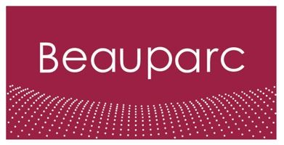
Job Description – Beauparc
Job Title | Regional Manager
Reports to | UK Processing Director

Purpose
As the Regional Manager you will be responsible for the overall management and growth of your assigned region. You will have full P&L accountability and will focus on delivering excellent customer service levels, maintaining high operational standards, and driving efficiency across all operations.

Your role requires leadership skills to drive team performance, manage contracts, oversee projects, and collaborate effectively with stakeholders across waste collection authorities and internal teams.

Key accountabilities
P&L Accountability and Growth:
- Hold full P&L accountability for the region and work towards profitable growth targets through strategic initiatives and operational efficiency.

Customer Service and Operational Excellence:
- Ensure excellent customer service levels and maintain high operational standards across all recycling centres, transfer stations, and the haulage fleet.
- Identify bottlenecks, implement process improvements, and drive operational excellence with a focus on scalability and efficiency.

Contract Management:
- Collaborate closely with the central contract management function to ensure major contractors are compliant and delivering excellent levels of service.

Project Management:
- Undertake assigned projects, ensuring on-time delivery, within budget, and meeting expected standards.
Stakeholder Management:
- Work closely with Waste Collection Authorities, providing effective waste disposal and treatment directions.

Team Leadership and Development:
- Set clear performance objectives, provide regular feedback, coaching, and support to team members to drive their professional growth and development.

Reporting and Communication:
- Report operational performance, trends, and actionable insights to the leadership team, supporting informed decision-making.

Experience and Skills
- Proven experience in a managerial role within the waste management or processing industry.
- Strong leadership, communication, and interpersonal skills with the ability to influence and drive strategic initiatives.
- Project management skills with the ability to deliver outcomes on time, within budget, and to expected standards.
- Results-oriented mindset with a focus on customer service, operational excellence, and business growth.
- Ability to work collaboratively with peers, stakeholders, and internal teams to achieve common goals.
- Strong interpersonal and communication skills with ability to influence and drive strategic initiatives.
- Knowledge of health and safety regulations in a processing and operational environment.

Qualifications and Knowledge
Knowledge of health and safety regulations in a processing and operational environment.

Beauparc aims to attract and retain a skilled and diverse workforce that best represents the talent available in the communities in which our assets are located and our employees reside.
(DE&I Policy Statement)

