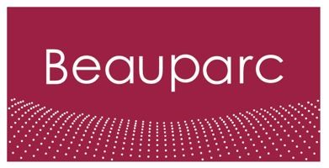
Job Description – Beauparc
Job Title | SHEQ Coordinator
Reports to | Regional SHEQ Manager

About Us

Beauparc is a leading waste and utilities business ideally positioned to be part of the solution to some of the main environmental problems facing society today: reducing waste, avoiding pollution, and preventing the unnecessary use of finite natural resources. As a Group, Beauparc employs approximately 3200 employees over 44 locations in 6 countries in Europe primarily in the UK and Ireland. Above all, our team is committed and passionate about our vision to ensure that we work together to create a safer environment for our people, planet, and partners

Key Responsibilities

- Work under the direction of the Regional SHEQ Manager to achieve business objectives
- Assist and drive plans for SHEQ related activities to ensure the organisation achieves excellent levels of health, safety and environmental performance.
- Ensure all accidents, incidents, near misses and non-conformities are correctly reported and investigated in accordance with company procedure.
- Effectively maintain accident report files, incident files, accident investigations, corrective actions to prevent reoccurrence, and other related safety concerns.
- Produce monthly reports from the health & safety and environment department with regards to company performance.
- Develop a relationship with the direct line operational leaders, contribute to functional developments to ensure full compliance of the business with Group requirements.
- Review and create necessary SHEQ documents (risk assessments, safe systems of work & CoSHH
- Develop and maintain the business unit’s management systems
- Be responsible for document control for our management systems •Conduct and document environmental checks on our operational sites
- Organise external surveys and assessments when required ensuring records of corrective action
- Manage the contractor control database ensuring all documents are maintained
- Manage the off-taker waste destination list ensuring all documents are maintained

Training / Qualifications

- Experience in a similar role would be beneficial however other experience will be considered
- Qualified to IOSH Managing Safely
- NEBOSH General Certificate level or willingness to obtain
- Self-motivated and confident •Microsoft Office skills
- Full Driving Licence

